**Batch:B2**

**Roll Number: 16010420061 Experiment No:3**

**Name:Sargundeep Sachdeo**

**Title of the Experiment:Execution of classification algorithm using Rapidminer.**

**Program:**

**Decision Tree:  
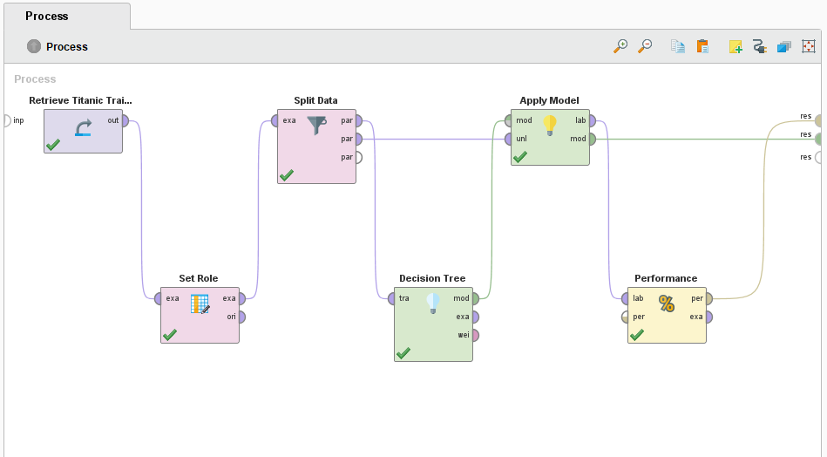**

**Naive Bayes:**

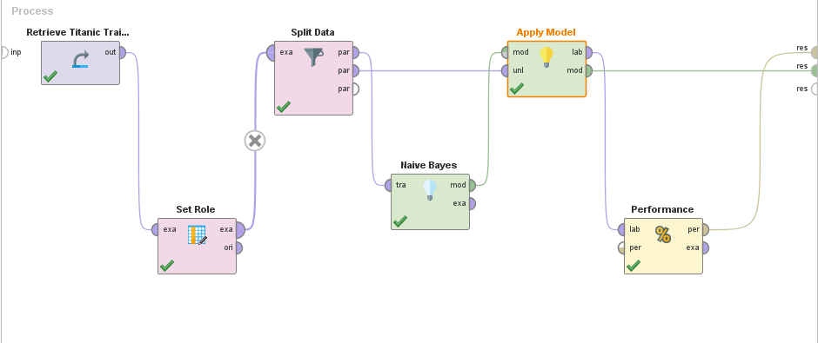

**Output:**

**Decision Tree:**

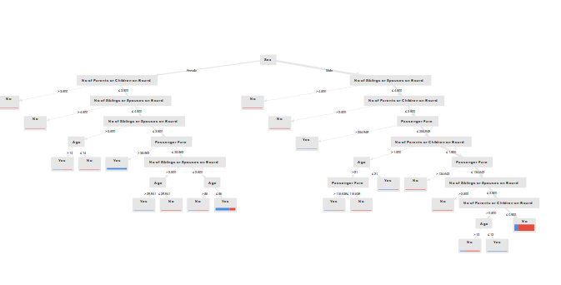

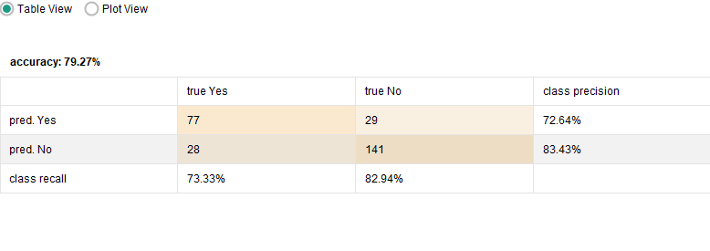

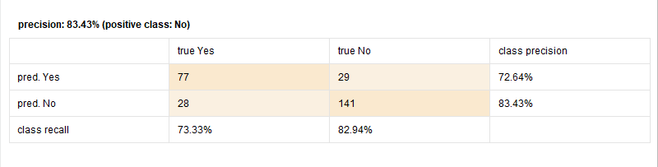

**Naive Bayes:**

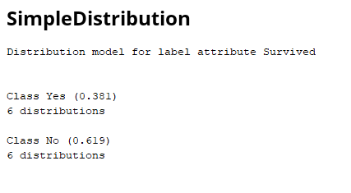

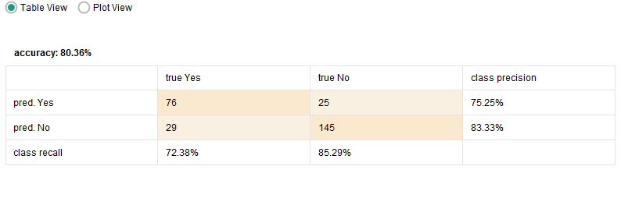

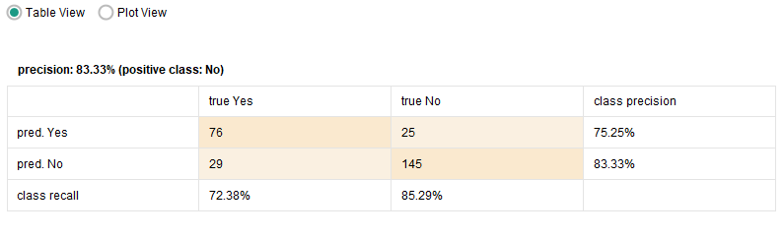

**Analysis: The dataset chosen for model training is Titanic Dataset.When this is trained with Naive Bayes model , it shows higher accuracy than Decision Tree.**

**Post Lab Question- Answers (If Any):**

**Q: List any five open sources / freeware tools available for data mining.**

**Ans:**5 best open source data mining tools:.

1. Apache Mahout: A well-liked distributed linear algebra framework is Apache Mahout. It is a mathematical representation of the Scala DSL, which enables statisticians and data scientists to quickly build their methods. Multiple backends, including Apache Spark, are supported by the tool. Mahout enables apps to analyse huge datasets more quickly.

2. ELKI: Environment for Developing KDD-Applications Supported by Index-Structures is referred to as ELKI. It is a Java-based open-source data mining programme. The platform is made for studying algorithms. The ELKI platform aims to conduct algorithmic research with an emphasis on unsupervised cluster analysis techniques. Data index structures like the R*-tree are offered by ELKI. The platform provides a vast array of extremely parameterizable algorithms.

3. KNIME: The Java-based framework was created using Eclipse. It is a multilingual environment for developing applications. KNIME is a free platform for data reporting, analytics, and integration. It offers a user-friendly interface and 2000 nodes from which you can pick to build visual workflows.

4. Orange: A variety of data visualisation, exploration, preprocessing, and modelling strategies work best with the open-source, component-based data mining software for machine learning and data visualisation. Orange offers interactive data visualisation with basic data analysis capabilities.

5. Rattle: Data summaries are presented statistically and visually using this open-source GUI for data mining. Rattle enables data transformation for quick modelling. Additionally, it creates data-driven supervised and unsupervised ML models. The finest aspect of Rattle is that it makes extensive use of R's statistical capabilities to offer data mining functionality.

**CO:** Comprehend basics of ML

**Conclusion:** In this experiment, I successfully understood and implemented classification algorithms on Titanic Dataset using Rapid Miner